Partial / residual correlation: GBPUSD and USDCHF
Method 07 / daily log returns / leave-currency-out USD factor / Alpari D1 full available history

Study setup
Logical pair: GBPUSD , USDCHF
Broker symbols: GBPUSD_i , USDCHF_i
Snapshot: 2026-11-03_majors_alpari_D1
Timeframe: D1
Matched return window: 1999-01-05 to 2026-11-02 (UTC bar dates)
Matched return count n: 7148
Dropped unfinished last bar dated 2026-11-03 UTC after a tick-volume check against the prior complete day.
USD-strength sign rule: minus log return when USD is the quote (EURUSD, GBPUSD, AUDUSD, NZDUSD); plus log return when USD is the base (USDJPY, USDCHF, USDCAD). EURGBP is never a constituent.
Control z constituents (5): EURUSD, AUDUSD, NZDUSD, USDJPY, USDCAD
z_t = equal-weight mean of those USD-strength returns on the same day
Complete matched rows (Excel): GBPUSD-USDCHF_Partial_D1.xlsx
Complete matched rows (HTML table): GBPUSD-USDCHF_Partial_D1_data.html

Method carried forward
Partial / residual correlation regresses each matched daily log return of close, ln(close_t / close_t-1), on the same leave-currency-out USD strength factor z, then takes Pearson correlation of the two residual series. Quotes are not inverted. z is the equal-weight mean of USD-strength returns from other majors that do not share a non-USD currency with either leg; EURGBP is never a constituent. USD-strength is minus the log return when USD is the quote (EURUSD, GBPUSD, AUDUSD, NZDUSD) and plus the log return when USD is the base (USDJPY, USDCHF, USDCAD). OLS uses an intercept on each leg. rho_partial is symmetric under swap of the two symbols. It describes leftover linear co-movement after removing linear z; it is not a cause, not a lead, and not a trading signal. Daily rows are not independent and residuals are estimated, so the two-sided p-value and Fisher interval are secondary. Same-sample raw Pearson r is a side check only.

Regression on z
leg | intercept_a_or_c | slope_b_or_d | R2
GBPUSD | -2.115e-05 | -0.75775125 | 0.41453663
USDCHF | -6.812e-05 | 0.81679278 | 0.3532724

Results
rho_partial: -0.165833
Two-sided p-value: 3.03249e-45
Approximate 95% Fisher interval: [-0.188292, -0.143200]
Same-sample raw Pearson r: -0.484723
rho_partial minus r: 0.318890

Conclusion
Over 7148 matched daily rows for GBPUSD and USDCHF after removing a leave-currency-out USD factor built from 5 constituents, rho_partial is -0.1658 (negative, weak residual linear link in this sample). Approximate 95% Fisher interval: [-0.1883, -0.1432]. Same-sample raw Pearson r is -0.4847 (partial minus r = 0.3189). Leg R-squared on z: GBPUSD=0.4145, USDCHF=0.3533. Two-sided p under the usual independent-pairs model is 3.032e-45; residuals are estimated and daily FX rows are linked, so treat p as secondary. This does not establish cause, lead-lag, or a lasting trading rule.

Charts
Daily closes
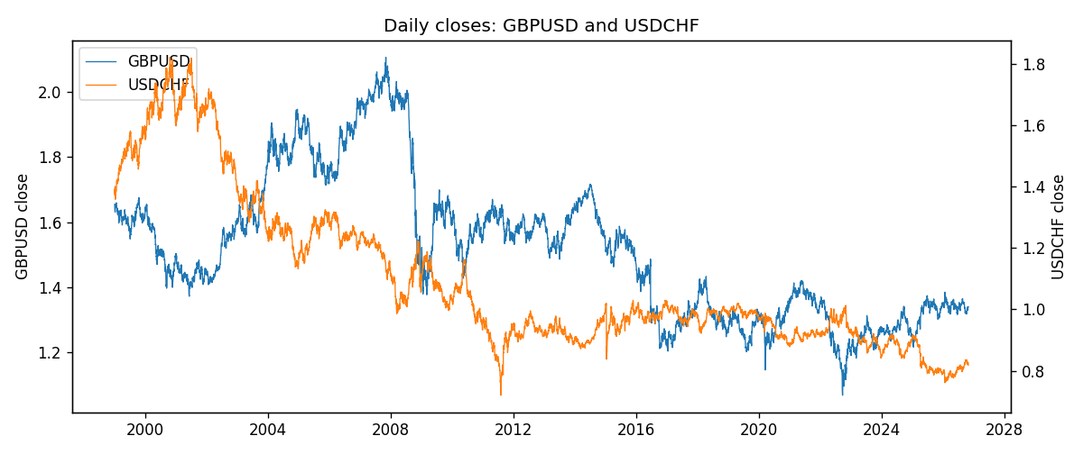
Log returns and control z
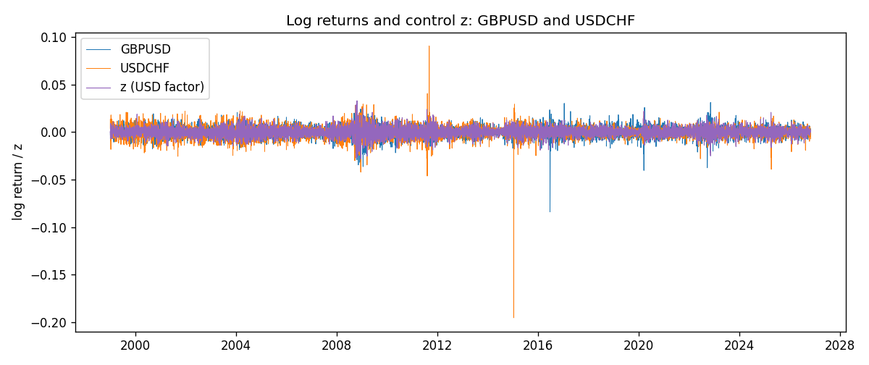
Residual scatter e_x vs e_y
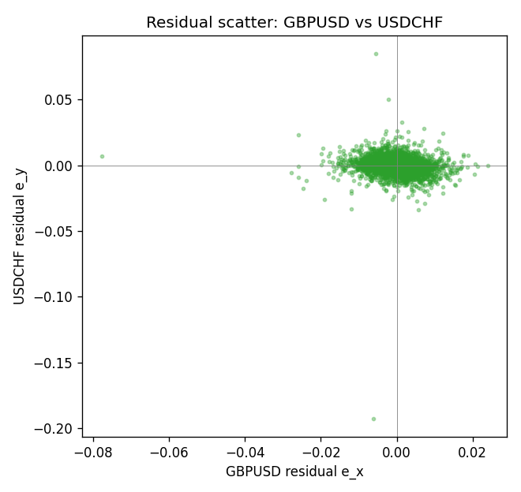

Data report
Every matched row that entered the partial correlation is stored in the sibling Excel workbook named GBPUSD-USDCHF_Partial_D1.xlsx. That file is the complete data archive for redrawing charts. Embedding all rows as a Word table is impractical at this length; the Word file holds the column list, column summaries, and the first and last 15 matched rows.
Columns: time, GBPUSD_open, USDCHF_open, GBPUSD_high, USDCHF_high, GBPUSD_low, USDCHF_low, GBPUSD_close, USDCHF_close, GBPUSD_tick_volume, USDCHF_tick_volume, GBPUSD_spread, USDCHF_spread, GBPUSD_real_volume, USDCHF_real_volume, GBPUSD_log_return, USDCHF_log_return, usd_strength_EURUSD, usd_strength_AUDUSD, usd_strength_NZDUSD, usd_strength_USDJPY, usd_strength_USDCAD, z, GBPUSD_fitted, USDCHF_fitted, GBPUSD_resid, USDCHF_resid
Column summaries (matched calculation rows)
column | count | mean | std | min | 25% | 50% | 75% | max
GBPUSD_open | 7148 | 1.5147424 | 0.21801364 | 1.06854 | 1.3240425 | 1.50985 | 1.629975 | 2.1066
USDCHF_open | 7148 | 1.0960885 | 0.25173228 | 0.72022 | 0.9203525 | 0.9894 | 1.2355 | 1.8219
GBPUSD_high | 7148 | 1.5210395 | 0.21858109 | 1.08366 | 1.32902 | 1.516685 | 1.6374625 | 2.1161
USDCHF_high | 7148 | 1.101368 | 0.25346299 | 0.73305 | 0.9245 | 0.993025 | 1.240225 | 1.8313
GBPUSD_low | 7148 | 1.5084277 | 0.21724232 | 1.03518 | 1.3186875 | 1.50192 | 1.6233 | 2.0983
USDCHF_low | 7148 | 1.0909798 | 0.25015306 | 0.08565 | 0.9169075 | 0.98582 | 1.229425 | 1.8121
GBPUSD_close | 7148 | 1.5148153 | 0.21797449 | 1.06879 | 1.324035 | 1.50993 | 1.6299575 | 2.1065
USDCHF_close | 7148 | 1.0960817 | 0.25162815 | 0.72025 | 0.92048 | 0.989445 | 1.2352 | 1.8217
GBPUSD_tick_volume | 7148 | 95468.138 | 153933.58 | 62 | 10088.75 | 53396.5 | 92022.25 | 1273370
USDCHF_tick_volume | 7148 | 74666.538 | 113693.11 | 350 | 12884 | 40421 | 70666.5 | 858589
GBPUSD_spread | 7148 | 26.846531 | 19.190643 | 0 | 10.75 | 20 | 50 | 50
USDCHF_spread | 7148 | 25.894096 | 24.64185 | 0 | 5 | 16 | 50 | 100
GBPUSD_real_volume | 7148 | 3.582457e+09 | 8.4750162e+10 | 0 | 0 | 0 | 0 | 2.4038164e+12
USDCHF_real_volume | 7148 | 2.3408849e+10 | 8.9348471e+10 | 0 | 0 | 0 | 0 | 1.9331921e+12
GBPUSD_log_return | 7148 | -1.992e-05 | 0.00564699 | -0.08388241 | -0.0031217 | 3.426e-05 | 0.00318167 | 0.03112653
USDCHF_log_return | 7148 | -6.945e-05 | 0.0065937 | -0.19545699 | -0.00334697 | 8.15e-05 | 0.00331954 | 0.09051364
usd_strength_EURUSD | 7148 | 2.16e-06 | 0.0058013 | -0.03433183 | -0.00325609 | -0 | 0.00324218 | 0.03123819
usd_strength_AUDUSD | 7148 | -3.157e-05 | 0.00755018 | -0.0806166 | -0.00415111 | -0.00029168 | 0.00385014 | 0.08602525
usd_strength_NZDUSD | 7148 | -1.914e-05 | 0.00764519 | -0.05966839 | -0.004586 | -0.00023666 | 0.00424201 | 0.07027433
usd_strength_USDJPY | 7148 | 5.267e-05 | 0.00620906 | -0.03908203 | -0.00319392 | 0.00012736 | 0.00340928 | 0.05184024
usd_strength_USDCAD | 7148 | -1.226e-05 | 0.00514518 | -0.03859748 | -0.00283513 | 4.873e-05 | 0.00272781 | 0.03436319
z | 7148 | -1.63e-06 | 0.00479813 | -0.02824205 | -0.00275442 | -2.851e-05 | 0.00274051 | 0.032932
GBPUSD_fitted | 7148 | -1.992e-05 | 0.00363579 | -0.02497542 | -0.00209778 | 4.5e-07 | 0.00206601 | 0.0213793
USDCHF_fitted | 7148 | -6.945e-05 | 0.00391908 | -0.02313603 | -0.00231791 | -9.141e-05 | 0.00217031 | 0.0268305
GBPUSD_resid | 7148 | -0 | 0.00432083 | -0.07773677 | -0.00227693 | 6.036e-05 | 0.00237664 | 0.02390884
USDCHF_resid | 7148 | -0 | 0.00530261 | -0.19249567 | -0.00237397 | 9.681e-05 | 0.00249976 | 0.08484367
First 15 matched rows (selected columns)
time | GBPUSD_close | USDCHF_close | GBPUSD_log_return | USDCHF_log_return | z | GBPUSD_fitted | USDCHF_fitted | GBPUSD_resid | USDCHF_resid
1999-01-05 | 1.6547 | 1.3724 | -0.0028966287 | 0.0039424743 | -0.00056206853 | 0.00040475392 | -0.00052721339 | -0.0033013826 | 0.0044696877
1999-01-06 | 1.6537 | 1.3912 | -0.00060452184 | 0.013605652 | 0.00098027876 | -0.00076396166 | 0.00073256474 | 0.00015943982 | 0.012873087
1999-01-07 | 1.6502 | 1.3782 | -0.002118709 | -0.0093883841 | -0.0068241559 | 0.0051498584 | -0.0056420412 | -0.0072685674 | -0.0037463429
1999-01-08 | 1.6405 | 1.3935 | -0.0058954193 | 0.011040268 | 0.0008640193 | -0.00067586591 | 0.00063760485 | -0.0052195534 | 0.010402663
1999-01-11 | 1.6312 | 1.4009 | -0.0056851331 | 0.0052963193 | -0.0060235439 | 0.0045431937 | -0.004988107 | -0.010228327 | 0.010284426
1999-01-12 | 1.6349 | 1.3872 | 0.0022657001 | -0.0098275602 | 0.0089192122 | -0.0067796983 | 0.0072170282 | 0.0090453984 | -0.017044588
1999-01-13 | 1.6499 | 1.3621 | 0.0091330396 | -0.018259701 | 0.0039396851 | -0.0030064555 | 0.0031497865 | 0.012139495 | -0.021409487
1999-01-14 | 1.6531 | 1.3588 | 0.0019376331 | -0.0024256692 | 0.001964044 | -0.001509411 | 0.0015360971 | 0.0034470441 | -0.0039617663
1999-01-15 | 1.6502 | 1.3834 | -0.0017558204 | 0.01794228 | 0.00072337184 | -0.00056929012 | 0.00052272502 | -0.0011865303 | 0.017419555
1999-01-18 | 1.6522 | 1.379 | 0.0012112405 | -0.0031856384 | -0.00032816001 | 0.00022750944 | -0.0003361586 | 0.00098373101 | -0.0028494798
1999-01-19 | 1.6553 | 1.3789 | 0.0018745281 | -7.2518946e-05 | -0.0023566724 | 0.0017646172 | -0.0019930329 | 0.00010991091 | 0.0019205139
1999-01-20 | 1.6472 | 1.3889 | -0.0049053846 | 0.0072259871 | -0.0026977808 | 0.0020230926 | -0.0022716478 | -0.0069284771 | 0.0094976349
1999-01-21 | 1.6524 | 1.3836 | 0.0031518998 | -0.0038232689 | -0.00073625094 | 0.00053674085 | -0.00066948433 | 0.002615159 | -0.0031537845
1999-01-22 | 1.6565 | 1.3834 | 0.0024781662 | -0.0001445609 | 0.0068117967 | -0.0051828016 | 0.0054957065 | 0.0076609678 | -0.0056402674
1999-01-25 | 1.6585 | 1.3868 | 0.0012066366 | 0.0024546976 | 0.0008062273 | -0.00063207395 | 0.00059040077 | 0.0018387106 | 0.0018642969
Last 15 matched rows (selected columns)
time | GBPUSD_close | USDCHF_close | GBPUSD_log_return | USDCHF_log_return | z | GBPUSD_fitted | USDCHF_fitted | GBPUSD_resid | USDCHF_resid
2026-10-13 | 1.32534 | 0.83244 | 0.0036434319 | -0.0024955621 | -0.0037013062 | 0.0027835152 | -0.0030913201 | 0.00085991667 | 0.00059575803
2026-10-14 | 1.31884 | 0.83489 | -0.0049164679 | 0.0029388325 | 0.0021204941 | -0.0016279613 | 0.0016638844 | -0.0032885067 | 0.0012749481
2026-10-15 | 1.32757 | 0.82676 | 0.0065976411 | -0.0097855323 | -0.0016573344 | 0.001234693 | -0.0014218187 | 0.0053629481 | -0.0083637136
2026-10-16 | 1.33257 | 0.82377 | 0.0037592051 | -0.0036230826 | -0.0029450397 | 0.0022104533 | -0.002473607 | 0.0015487518 | -0.0011494756
2026-10-19 | 1.33024 | 0.82677 | -0.0017500314 | 0.0036351779 | -0.00056541952 | 0.00040729314 | -0.00052995046 | -0.0021573246 | 0.0041651284
2026-10-20 | 1.3377 | 0.8246 | 0.0055923442 | -0.0026281224 | -0.0031062818 | 0.0023326347 | -0.0026053084 | 0.0032597095 | -2.2813961e-05
2026-10-21 | 1.33937 | 0.82427 | 0.0012476328 | -0.00040027413 | -0.0015108515 | 0.0011236954 | -0.0013021724 | 0.00012393747 | 0.00090189831
2026-10-22 | 1.33967 | 0.82032 | 0.00022396082 | -0.0048036381 | -0.0010118509 | 0.00074557708 | -0.0008945924 | -0.00052161626 | -0.0039090457
2026-10-23 | 1.33684 | 0.82497 | -0.0021146949 | 0.005652514 | -0.00075033418 | 0.00054741245 | -0.00068098742 | -0.0026621074 | 0.0063335014
2026-10-26 | 1.33359 | 0.82649 | -0.0024340661 | 0.0018407959 | 0.0025108626 | -0.0019237635 | 0.0019827346 | -0.00051030263 | -0.00014193866
2026-10-27 | 1.33044 | 0.82865 | -0.0023648393 | 0.0026100526 | 0.0016104929 | -0.0012415072 | 0.0012473191 | -0.0011233321 | 0.0013627335
2026-10-28 | 1.33254 | 0.82781 | 0.0015771808 | -0.0010142111 | -0.00027683563 | 0.00018861833 | -0.00029423722 | 0.0013885624 | -0.00071997389
2026-10-29 | 1.33733 | 0.82379 | 0.0035881935 | -0.0048680164 | 0.0001435418 | -0.00012992319 | 4.9124031e-05 | 0.0037181167 | -0.0049171404
2026-10-30 | 1.33913 | 0.82438 | 0.0013450605 | 0.00071594559 | -0.00042985827 | 0.00030457143 | -0.00041922501 | 0.001040489 | 0.0011351706
2026-11-02 | 1.3406 | 0.81851 | 0.0010971256 | -0.0071459744 | 0.0017306536 | -0.0013325591 | 0.0013454655 | 0.0024296847 | -0.0084914399

